

SID: IT24101737

Name: Ekanayake E.M.B

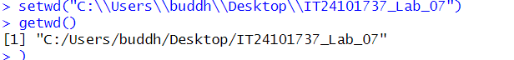

Figure 7.0: Set the file

Question 01

A train arrives at a station uniformly between 8:00 a.m. and 8:40 a.m. Let the random variable X represent the number of minutes the train arrives after 8:00 a.m. What is the probability that the train arrives between 8:10 a.m. and 8:25 a.m.?

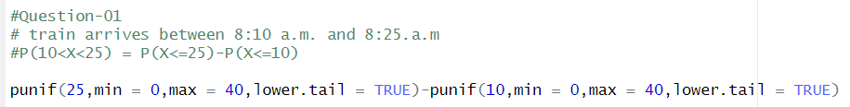

Figure 7.1: Question 01 R code



Figure 7.1: Q1 console part

Question 02

The time (in hours) to complete a software update is exponentially distributed with rate λ=1/3. Find the probability that an update will take at most 2 hours.

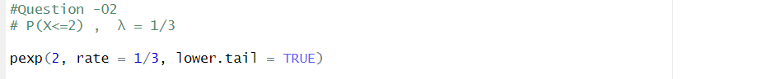

Figure 7.2: Question 02 R code





Figure 7.2: Question 02 console

Question-03

Suppose IQ scores are normally distributed with a mean of 100 and a standard deviation of 15.

1. What is the probability that a randomly selected person has an IQ above 130?

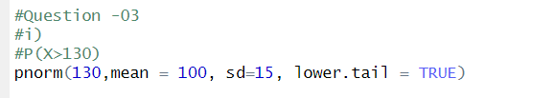

Figure 7.3.1: Question 03 R code

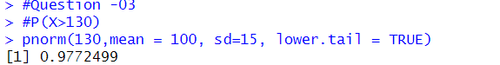

Figure 7.3.1: console part

1. What IQ score represents the 95th percentile?



Figure 7.3.2: Question 03 R code



Figure 7.3.2: console part